University of Central Punjab
Faculty of Information Technology
Assignment 1

Course: AI Due Date: 26-10-26 Topics:W1,W2,W3 Marks: 70

CLO # | Course Learning Outcome Statement | Taxonomy Level
CLO1 | Students will understand the solid fundamental principles and concepts of artificial intelligence, including machine learning and neural networks. | C2
CLO2 | Students will be able to design and implement AI applications that solve real-world problems. | C3
Instructions:
- Please submit handwritten assignment during class.
- Late submission would result in deduction of 25% marks.

----------------------------------------------------------------------------------------------------------------
Question 1 [20 Marks]
Express PEAS description of following Task envoirnments:
a. Online Retail Recommendation System (e.g., Amazon's Recommendations):
b. Weather Forecasting
c. Language Translation
d. Stock Market Prediction
Question # 2: [20 Marks]
Describe problem formulation in terms of initial state, goal test, transition function and cost function:
- Navigation Problem (e.g., GPS navigation)
- Job Scheduling for CPU in an Operating System
- Network Routing Problem
- Elevator Control System

Question # 3: [10 +10 +10 Marks]
Apply the given algorithms to solve out the order in which nodes are added to the explored set, with start state ‘A’ and goal state ‘G’. Additionally, what is the path returned by each algorithm? What is the total cost of each path? (Refer to lecture slides for methods)
- Breadth-first Search
- Depth – first Search
- Uniform cost Search

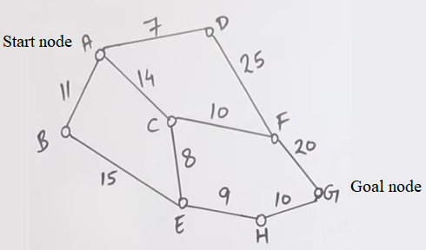
*Dear Students
At first put arrows from start node A towards Goal node G, after that make tree of this graph from A to G. Then solve it using the given algorithms.

